What difference between IGW & NAT Gateway
Internet Gateway | NAT Gateway
Connects a VPC to the internet | Enables outbound traffic from a private subnet to the internet
Acts as a virtual router between a VPC and the internet | Translates private IP addresses of instances to public IP addresses
Required for resources within a VPC to be accessible from the internet | Used when resources within a private subnet require internet access but should not be directly accessible from the internet
Instances within a public subnet must have public IP addresses to communicate with the internet | Instances within a private subnet can have private IP addresses
Used for hosting publicly accessible resources like web servers | Used for instances that need to access the internet for updates or data retrieval
Traffic is routed directly to the internet | Traffic is routed through the NAT Gateway before going to the internet
Can be attached to only one VPC | Can be shared across multiple VPCs
Does not modify the source IP address | Replaces the source IP address with its own IP address
It is typically used in corporate networks, where it serves as the default gateway for devices in the network. | A NAT gateway is typically used in smaller networks, such as home networks, where it is used to share a single internet connection between multiple devices.
Internet Gateway serves as a point of entry and exit for network traffic between a private network and the internet | NAT Gateway is used to translate private IP addresses into public IP addresses and vice versa

NAT GATEWAY AND NAT INSTANCE
A NAT gateway is a fully managed, highly available, and scalable AWS service, while a NAT instance is a user-managed EC2 instance that performs the same function. NAT gateways are recommended for most use cases due to their high performance and low maintenance, whereas NAT instances may be cheaper initially but require manual scaling and patching. The main differences lie in management, availability, performance, and cost.
Feature | NAT Gateway | NAT Instance
Management | Fully managed by AWS. | Managed by the user, including OS and software updates.
Availability | Highly available by default, with redundancy in each Availability Zone. | Depends on the EC2 instance's Availability Zone; requires manual configuration for failover.
Performance | Scales up to 45 Gbps with high availability. | Performance is limited by the EC2 instance type and is not automatically scaled.
Maintenance | AWS handles all maintenance, patching, and updates. | Requires user to perform all maintenance, patching, and updates.
Cost | Higher cost due to being a managed service. | Lower cost initially, but requires time and resources for management, which adds to the overall cost.
Setup | Simpler and faster setup. | More complex setup, as you need to configure the EC2 instance, install software, and set up routing.
When to use which:
- Use a NAT Gateway for most production workloads where you need high availability, high performance, and minimal administrative overhead.
- Use a NAT Instance only if you have a specific use case that requires the customization offered by an EC2 instance, such as using custom routing rules or specific software, and you are prepared to manage the instance yourself

AWS VPC Flow Logs
Amazon VPC Flow Logs is a feature that enables you to capture and log the information about the network traffic going to and from the designated network interfaces within your VPC. It can be used as a centralized, single source of information to monitor different network aspects of your VPC.
Kinds of VPC Flow Logs
It is very much important to understand what is monitored and how the logs compile the data. Amazon Web Service (AWS) Offers flow logging at three separate levels:
- Virtual Private Cloud (VPC): Flow logs can be enabled to a particular VPC and can monitor all the activity within your cloud environment.
- Subnet: VPCs are often divided into subnets spanning multiple availability zones in a region. A subnet is a range of IP addresses in your VPC. It can be a private or a public one. Flow Logs can be created for a specific subnet to monitor all the activity within your subnet.
- Elastic Network Interface (ENI): ENIs are virtual network cards you can attach to your EC2 instances. They are used to enable network connectivity for your instances. One can monitor and capture full flow logs from these interfaces to stay ahead of issues like latency and malicious activities.
Enabling VPC Flow Logs
You can enable VPC Flow Logs from the AWS Management Console or the AWS Command Line Interface (CLI), or by making calls to the EC2 API. By default, VPC is not enabled.
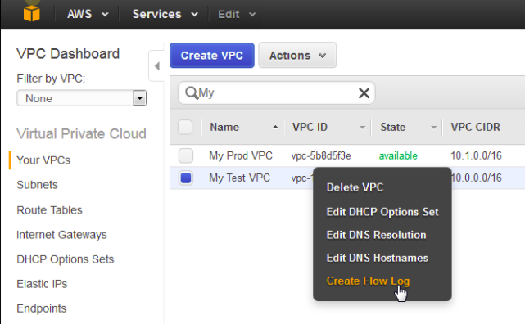
To Create a Flow log, you need to specify:
- Resource for which to create the flow log (By using the above method, this will be automatically filled up)
- Type of traffic to capture (accepted traffic, rejected traffic, or all traffic).
- Destinations to which you want to publish the flow log data.
Publishing Flow Logs
VPC Flow Logs can be sent to either
- CloudWatch Logs: To send Flow log data to the CloudWatch log group, a log group must be created to specify.
- S3 Bucket: To send Flow log data to Amazon S3, you'd need an existing S3 bucket to specify.
VPC Flow Logs Use Cases:
- Network Monitoring: It provides you with real-time visibility into network throughput and performance
- Network Usage and optimizing network expenses: You can analyze the network usage and based on the analysis, you can optimize the network traffic expenses.
- Network Forensics: You can find out any compromised IPs by analyzing all the incoming and outgoing network flows In case of any incidents.
VPC Flow Logs Limitations:
- You can't enable flow logs for VPCs that are peered with your VPC unless the peer VPC is in your account
- Once a flow log is created, you cannot change its configuration or the flow record format
- Flow Logs also exclude certain types of traffic like DHCP traffic, Mirrored traffic, Traffic generated by a Windows instance for Amazon windows license activation, DNS activity.

IAM (IDENTITY ACCESS MANAGEMENT)
In AWS, IAM (Identity and Access Management) is the service you use to control who can access what. It lets you create and manage users, groups, and roles, and you use policies to define the permissions they have to use AWS services and resources. Access is denied by default, and you must grant permissions explicitly.
Key concepts
- Users: Individual people or applications that need to access AWS.
- Groups: Collections of users. You can attach permissions to a group, and all users in that group will have those permissions.
- Roles: A set of permissions that can be "assumed" by trusted users or services to get temporary credentials to access resources. This is a core concept for granting AWS services access to other services.
- Policies: JSON documents that define permissions. A policy specifies what actions (like s3:GetObject) are allowed or denied on which resources (like an S3 bucket).
How it works
- Create identities: You can create users, groups, or roles.
- Define permissions: You create policies that specify the allowed or denied actions.
- Attach policies: You attach the policies to users, groups, or roles.
- Grant access: When a user or role tries to perform an action, AWS checks the attached policies to see if access is explicitly allowed.
- Best practices: To improve security, follow the Principle of Least Privilege (give only the necessary permissions) and enable Multi-Factor Authentication (MFA).
IAM ROLE
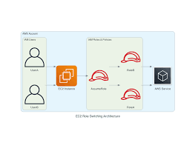
An AWS IAM role is a secure identity with permissions that can be temporarily assumed by trusted entities, like users, applications, or services, to perform actions in your AWS account. Unlike an IAM user with long-term credentials, a role uses temporary security credentials, which significantly reduces the risk of compromised access. They are ideal for granting cross-account access or allowing services like EC2 instances or Lambda functions to access other AWS resources.
Key characteristics
- Temporary credentials: When a role is assumed, it provides temporary credentials that automatically expire, which is a security best practice.
- Assumed by trusted entities: Anyone or anything, such as an application, an AWS service, or even another AWS account, can "assume" a role to get the permissions it defines.
- Permissions: An IAM role has permissions policies attached to it that define what actions it is allowed to perform on which AWS resources.
- No long-term access keys: Roles do not require long-term access keys, unlike IAM users, which makes them more secure for programmatic access.
How it works
- Trusted entity: A trusted entity, like an EC2 instance, is configured to assume a specific role.
- Permissions: The role has policies that define what it can do, such as read from an S3 bucket.
- Assumption: When the EC2 instance needs to perform an action, it assumes the role and receives temporary security credentials.
- Authorization: The instance uses these credentials to perform the authorized action on the resource.

Amazon VPC - Introduction to Amazon Virtual Private Cloud
A VPC is an on-demand, configurable pool of shared cloud resources allocated within a public cloud environment, providing a logically isolated section of that provider's infrastructure. It functions as a private, virtualized network that mirrors a traditional on-premises data center but is endowed with the scalability and agility of the cloud. By creating a VPC, an organization carves out its own secure and private space, transforming the open public cloud into a manageable domain where its data and applications are not commingled with those of other tenants.
This architectural choice yields several strategic benefits:
- Security: The logical isolation of a VPC is its paramount feature. It creates a secure environment with strict access controls, ensuring that resources are shielded from unauthorized access and isolated from other customers of the cloud provider.
- Agility and Scalability: A VPC allows an organization to fully control its virtual network size and deploy or scale cloud resources in real time as needs change, unconstrained by the physical limitations of hardware procurement and installation.
- Availability: VPCs are designed to leverage the cloud provider's underlying infrastructure, which includes fault-tolerant architectures spanning multiple physical data centers, known as Availability Zones. This provides inherent redundancy and high availability for deployed applications.
- Affordability: Organizations gain the functionality of a private cloud without the significant capital expenditure on hardware, maintenance, and labor. They benefit from the public cloud's pay-as-you-go model, while the provider manages the upkeep of the physical servers.
Example
Let's try to understand it by taking an example of the GeeksforGeeks office setup. Just like GeeksforGeeks carefully organizes its departments and controls access, a VPC organizes and secures resources in the AWS cloud.
- The entire GeeksforGeeks office building = VPC (a private space where everything is managed securely)
- Different departments like Editorial, Development, HR = Subnets (some open for external interaction, some private for internal work)
- Security guards at every gate = Security Groups and Firewalls (deciding who can enter or leave)
- The internet connection for employees and visitors = Internet Gateway (allowing public access where needed)
- Private tunnels connecting to partner companies = VPN or Direct Connect (secure, private connections to other trusted networks)
Amazon VPC Architecture Overview
The basic architecture of a properly functioning VPC consists of many distinct services such as Gateway, Load Balancer, Subnets, etc. Altogether, these resources are clubbed under a VPC to create an isolated virtual environment. Along with these services, there are also security checks on multiple levels.
It is initially divided into subnets, connected with each other via route tables along with a load balancer.
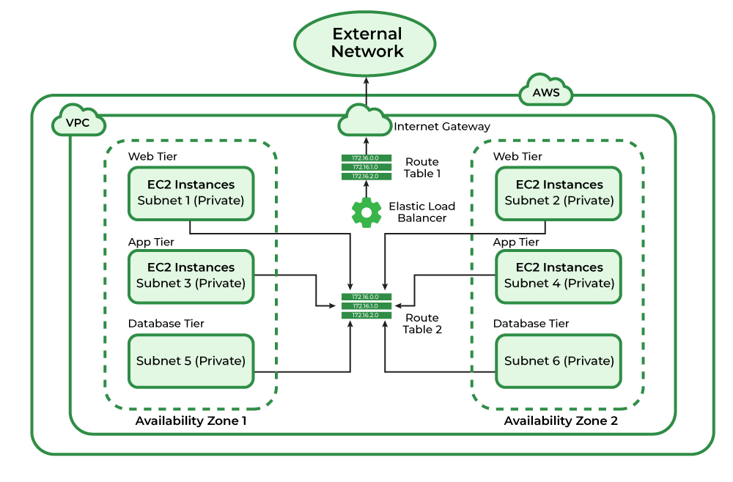
Core Components of Amazon VPC
The following are the components of Amazon VPC:
1. VPC
Virtual Private Cloud is a logically isolated section of the AWS cloud where resources can be launched, secured, and interconnected. Each VPC is defined by an IPv4 CIDR block (for example, 10.0.0.0/16), representing a user-defined address space of up to 65,536 IP addresses. This virtual network mirrors an on-premises data center but inherits the elasticity, scalability, and resilience of AWS’s global infrastructure.
2. Subnets
A Subnet is a segment of a VPC’s IP address range that resides entirely within a single Availability Zone (AZ).
Subnets serve two primary purposes:
- Segmentation: They divide large networks into smaller, isolated zones for better organization and control.
- High Availability: Distributing subnets across multiple AZs ensures fault tolerance and operational continuity.
Subnets are typically categorized as:
- Public Subnets, which route internet-bound traffic through an Internet Gateway (IGW).
- Private Subnets, which are isolated from direct internet access and communicate externally through a NAT Gateway.
This distinction forms the foundation of secure, multi-tier cloud architectures.

3. Route Tables
Each VPC contains an implicit virtual router that relies on Route Tables to direct traffic. Every subnet must be associated with exactly one route table, and each route defines:
- A destination CIDR block (where the traffic is headed).
- A target (where the traffic should be sent, such as an Internet Gateway, NAT Gateway, or another instance).
Route tables determine whether traffic remains internal to the VPC or is sent to external networks. They are the digital roadmap of the cloud network.
4. Network Access Control Lists
Network Access Control Lists (NACLs) are stateless firewalls that govern inbound and outbound traffic at the subnet level. Each VPC comes with a default NACL, which can be modified but not deleted. Unlike Security Groups, NACLs evaluate each packet individually and require explicit rules for both inbound and outbound flows. They are typically used to implement broad subnet-level controls, such as blocking specific IP ranges or enforcing compliance requirements across multiple instances.
5. Internet Gateway(IGW)
An Internet Gateway is a horizontally scaled, redundant component that enables bidirectional communication between public subnets and the internet. By attaching an IGW to a VPC and creating a route (e.g., 0.0.0.0/0) to it in a public subnet’s route table, instances within that subnet can send and receive traffic from the internet. A VPC can have only one attached Internet Gateway at a time. Without an IGW, no instance within the VPC can directly communicate with the public internet.
6. Network Address Translation (NAT)
NAT Gateways allow instances in private subnets to initiate outbound internet connections such as downloading updates or accessing APIs while preventing unsolicited inbound connections. This enables backend systems to communicate securely with external services without compromising isolation. In most architectures, NAT Gateways are deployed in public subnets, serving as controlled egress points for private subnets.
7. Security Groups
While NACLs operate at the subnet level, Security Groups act as stateful firewalls at the instance level. They define granular inbound and outbound rules based on IP ranges, ports, and protocols. Statefulness means that if an instance initiates an outbound connection, the return traffic is automatically allowed simplifying rule management. Security Groups form the first layer of defense for EC2 instances, RDS databases, and other VPC resources.
8. Classless Inter-Domain Routing (CIDR):
CIDR notation defines the IP range of a VPC or subnet, using syntax such as 10.0.0.0/16.
It provides flexibility in assigning and subdividing private address ranges as specified in RFC 1918, which includes:
- 10.0.0.0 - 10.255.255.255 (10/8)
- 172.16.0.0 - 172.31.255.255 (172.16/12)
- 192.168.0.0 - 192.168.255.255 (192.168/16)
These address blocks ensure isolation within private networks and avoid conflicts with public IP space
Use cases of Amazon VPC
The following are use cases of Amazon VPC:
- Hosting public-facing applications (e.g., web servers, load balancers) within public subnets.
- Deploying multi-tier architectures, where application and database layers reside in private subnets.
- Establishing secure interconnections between VPCs through peering or AWS Transit Gateway.
- Enforcing network security and compliance through traffic isolation, monitoring (VPC Flow Logs), and access control.
Amazon VPC (Virtual Private Cloud) Working
Follow the steps mentioned below to configure Virtual Private Cloud(VPC)
Step 1: Login into AWS Console and navigate to the
Step 2: After navigating to the AWS VPC now click on create VPC.
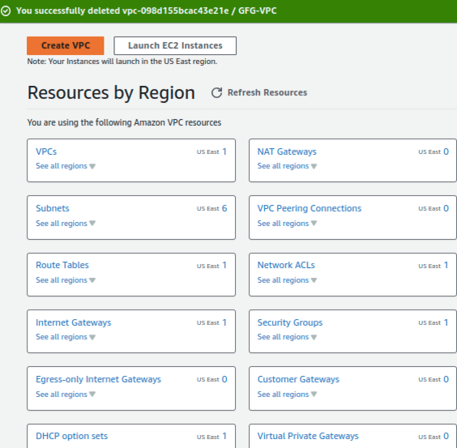
Step 3: Configure all the details required to create as shown in the image below. Some of the most required settings to configure VPC are as follows
- Name of the Network.
- IPv4 CIDR.
- And tags of VPC after that click on create VPC.
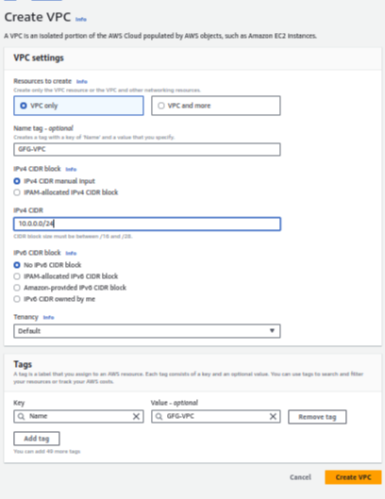
Step 4: Virtual Private Cloud created successfully with the required settings.

Step 5: Check the VPC dashboard whether the VPC created is available to use as shown in the image below GFG-VPC.
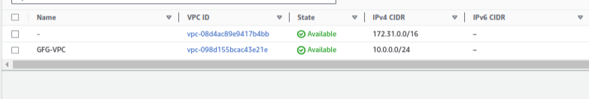

AWS VPC Console
To create and manage a Virtual Private Cloud (VPC) in AWS, follow these steps:
- Log in to your AWS account.
- Once inside the AWS Management Console, click on the “Services” menu at the top.
- From the list of categories, navigate to “Networking & Content Delivery”.
- Select “VPC” from the options provided.
After selecting VPC, you will be redirected to the VPC dashboard. On the left-hand side, the navigation pane displays various options and services related to VPC management.
Refer to the image attached below for a better understanding.

AWS - VPC Peering
Last Updated : 23 Jul, 2025

Virtual Private Cloud Peering is known as VPC Peering. It is an AWS networking function that provides safe and direct communication between different VPCs. By using the VPC peering feature organizations can establish private connections that facilitate the secure and smooth transfer of resources and data across various VPCs in the AWS Cloud. By establishing communication between different environments and maintaining the integrity of each VPC environment setting, VPC peering makes network management easier.
In the AWS ecosystem, VPC peering is an essential service for creating scalable, networked infrastructure structures. Amazon peering provides an effective way of linking Virtual Private Clouds (VPCs) and offers strong networking capabilities inside AWS. In this Article, the complexities of VPC peering are addressed with an effective way of explanation. This article clarifies how to establish smooth communication across different cloud environments in AWS.
Table of Content
- AWS VPC Peering Architecture
- AWS VPC Peering Connection Lifecycle
- How VPC Peering Works: Multi-VPC Connections
- Setup AWS VPC Peering Connections
- AWS VPC Peering Latency
- AWS VPC Peering Bandwith
- AWS VPC Peering Cross Account
- VPC Peering Limitations & Rules
- Pricing for a VPC Peering Connection
- AWS VPC Peering vs Transit Gateway
AWS VPC Peering Architecture
The following architecture diagram illustrates on usage of VPC peering connections to connect VPCs in your account with a VPC in the third-party account.

AWS VPC Peering Connection Lifecycle
The lifecycle of AWS VPC peering connection involves with serval key stages. Those are discuss as follow:
- Initiation: The life cycle process starts with initating a request to peer two VPCs. This request involves with specifying the VPCs to be peered and their respective settings.
- Approval: After the request is raised, the adminstrator of the receiving VPC have to accept that peering connection. This step involves both the parties to agress the connection establishment.
- Establishment: One Both approved the peering connection, the VPC peering connection is established. This enables the communication between two VPCs, if they were within same network, i.e., allowing instances in one VPC to communicate with other VPC's instance using private IP address.
- Configuration: After once, the connection is established, adminstrator may ensure configuring the route tables and security groups to control flow of the traffic between peered VPCs. This steps ensure the communication should be done in secured and follow with desired network paths.
- Utilization: With this peered connections, the resources within the peered VPCs can communicate with each other seamlessly. This provides various use cases such as data replication, resource sharing and application integration across multiple VPCs.
- Monitoring And Maintenance: Adminstrators continuously monitor the performance and security of the VPC peering connection. They may also perform the maintenance tasks such as updating route tables or adjusting security group rules as needed to optimize the connection's performance and ensuring its reliability.
- Termination ( Optional ): If need arises, the adminstrators can look for terminating the VPC peering connection. This effectively serves as the network link between the VPCs and prevents further communication between them.
How VPC Peering Works: Multi-VPC Connections
Multiple VPC peering connections are allowed for a network toplogy where multiple Virtual Private Clouds (VPCs) are interconnected. This provides the granular control over the communication between components or environments within an organization's cloud infrastructure. Each peering operates independent chanels and security configurations between specific VPC pairs. Adminstators can strategically deploy and manage mutiple peering connections to support many use cases such as multi-tiered application architectures, segregated development environments or distributed microservices deployments.
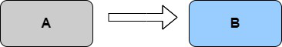
These VPCs can be in different regions and are hence known as inter-region VPC Peering connections.
How to Setup AWS VPC Peering Connections: A Step-By-Step Guide
Step 1: Navigate to VPC Dashbaord
- Sign in to your AWS account with your credentials.

- After Navigate to Console, you look into the following Console Home Page

- Select the VPC service in the search box.

Step 2: Create Virtual Private Network
- Create 2 VPC networks with names test-vpc-1 and test-vpc-2.
- Firstly, Click on the Create VPC button to create VPC.

- Configure the VPC details as shown in the below screenshot.

- Similarly define and create second vpc with name test-vpc-2 . Ensure that the CIDR of test-vpc-1 and test-vpc-2 doesn't overlay.

Step 3: Select "Peering Connections"
- Navigate to VPC Peering, and click on create VPC peering button.

- Provide the accepter VPC name and receiver VPC name.

Step 3: Click "Create Peering Connection"
- After creating the vpc peering connection, it will be in pending status .

Step 4: Accept Peering Connection
- Now, from the myvpc2 aws account, go to vpc peering dashboard, click on the accept request and accept the peering connection.

Step 5: Successful VPC Peering Connection
- After once the myvpc2 network accepts the request, the VPC peering connection will become active in status.

Step 6: Update Route Tables (if necessary)
- Ensure that the route tables for both VPCs are updated to include routes for each other's CIDR blocks, pointing to the peering connection.

Step 7: Verify Connectivity
- Now, Create an instance on each vpc and try on pinging the private IP of instance on each other instance.
- If they are successfully pinging then you have established VPC peering successfully.

Sometimes we need to allow resources in different VPCs to exchange data based upon the architecture of the service. Regardless of any specific need, using VPC peering is a great way of extending your VPC design.
Note: When you start to have a lot of peering connections between multiple VPCs, in multiple regions, across multiple AWS accounts, managing the connections. When it starts to get difficult, it is time to start looking at moving the existing peering connections to Transit Gateway and managing the connections there.
AWS VPC Peering Latency
AWS VPC Peering generally offers low level latency communication between the peered VPCs that are in same region. The traffic flows over the network, latency is generally minimal making it suitable for real-time applications and services. The latency is generally depends on the factors such as geographical distances between VPCs and potential network congestion which can slightly affect latency. AWS VPC peering is designed for efficient and reliable connectivity with minimal latency for inter-VPC communication.
AWS VPC Peering Bandwith
AWS VPC Peering connections offers scalable and high-bandwidth communication between peered VPCs. The bandwidth between the AWS VPCs depends on type of instances and its network capabilities of communication. AWS Direct Connect or AWS VPN connections can be used further for enhancing bandwidth between VPCs and on-premises networks also if needed.
AWS VPC Peering Cross Account
AWS VPC Peering Connection can be establishable across AWS Accounts known as cross-account VPC peering. This feature enables the organizations to establish secure and private ccommunication channels between VPCs that belonging to seperate AWS Accounts within same region. The cross account VPC peering requires explict acceptance from both the AWS Accounts, ensuring the adminstrators to maintain the control over the network access and security policies.
Advantages of VPC Peering
The following are the advantages of VPC peering:
- Seamless Communication: It helps in directing and securing the connection between the VPCs. It facilitates with this in sharing of resources and data transfers.
- Cost Efficiency: On establishing the private network communication based VPC peering removes the need of expensive public internet data transport making cost efficiency.
- Simplified Network Management: VPC peering simplifies the network architecture making it easier of network management and resolving complexities associated with traditional networking.
- Resource Access: VPC peering provides the access to the resources in different VPCs enhancing the efficiency of organizations services across interconnected networks.
VPC Peering Limitations & Rules
VPC Peering mechanism used in cloud for connecting multiple VPCs within same or different regions on the network. Even though it is a powerful tool, It is also comes up with some limitations. The following are the limitations of VPC Peering:
- No Transitive Peering: One of the primary limitations of VPC peering is not supporting temporary peering. Each Peering connection must be established individually to provide communication i.e., If VPC A is peered with VPC B and VPC is peered with VPC , VPC A cannot communicated directly with VPC C through VPC peering connection between A and B.
- CIDR Block Overlapping: For Establishing VPC Peering we have to ensure to maintain non-overlapping CIDR blocks to the VPCs. If CIDR overlaps then peering connection is not possible to establish.
- Limited Support For Transitive Routing: Transitive routing is not crucial for native VPC peering even though several cloud providers have developed features providing limited support on using through transit gateways or shared services.
- Cross Region Limitations: Usually VPC peering is limited to the same cloud Area. You might need to look at alternate options including VPN connection or cloud provider's inter-region peering services, if you need to link VPCs in various areas. This limitation can impact organizations with distributed or globally scattered infrastructure.
Pricing for a VPC Peering Connection
The following tabular format discusses the pricing details of VPC Peering:
Component | Description | Cost
VPC Peering Connection | It used for establishment of VPC Peering connection | $0.01 per GB
Data Transfer between VPCs | It used for transfering the data between VPCs | $0.02 per GB
NAT Gateway | If it is used for data transfer | Additional fee
Data Processing | If data processing has done in VPC | Variable  (Charge varies based on many parameters)
Support | It used for provding support to VPC Connection | Variable  (Charge varies based on many parameters)
AWS VPC Peering vs Transit Gateway
The following is the some of the main differences between AWS VPC peering and Transit Gateway:
Aspect | VPC Peering | Transist Gateway
Scope | It Connects the VPCs withing the same AWS region. | It connects with multiple VPCs and On-premises networks across AWS regions.
Topology | It establish point to point connections between individual VPCs. | It performs Hub and Spoke architecture with centrailized routing.
Communication | It establishes direct communication between the peered VPCs. | It performs centralized routing for inter-VPC and VPC-to-on-premises communication.
Scaling | Limited scaling, manual configuration is performed for each peering connection. | Highly scalable, supporting is provided for thousands of VPCs.
Transtivity | Not Transitive, Each VPC must establish seperate peering connections. | Transitive Routing, simplifying connectivity between mulitple VPCs.
Cost | data transfer costs between peered VPCs. | Transit gateway and data processing Charges apply on this.
.
AWS Transit Gateway
Last Updated : 23 Jul, 2025

In the powerful world of cloud computing, managing network availability between different parts can immediately become complex and challenging. Amazon Web Services (AWS) perceived this need and presented AWS Transit Gateway as a solution to work on network architecture and improve networks inside the AWS Cloud environment.
AWS Transit Gateway is a completely managed service intended to serve as a center point for interfacing numerous virtual private clouds (VPCs) and on-premises networks. It fills in as a main issue for routing and managing traffic, offering a versatile and productive answer for associations with different organizational necessities. In this article, we'll dive into the key terminologies, functionalities, and advantages of the AWS Transit Gateway. We'll explore its center ideas, step-by-step execution cycle, and address normal inquiries to give a complete comprehension of this fundamental AWS service.
Primary Terminologies
- AWS Transit Gateway: AWS Transit Gateway is a managed service provided by Amazon Web Services (AWS) that serves in as a center point for associating various VPCs and on-premises organizations. It works on network architecture by concentrating availability and routing, making it simpler to manage and scale network infrastructure inside AWS.
- Virtual Private Cloud (VPC): A virtual private cloud (VPC) is a virtual organization committed to an AWS account. It gives a coherently detached segment of the AWS Cloud where users can launch AWS resources, for example, EC2 instances, databases, and Lambda capabilities.
- Virtual Private Network (VPN): A virtual private network (VPN) is a solid association laid out between a user's network and AWS, normally utilized for reaching out to on-premises organizations in the cloud. VPN connections empower secure correspondence over the web by encrypting data communicated between the users network and AWS
- Route Tables: Route tables are utilized to control the routing of network traffic inside a VPC or between a VPC and outside organizations, With regards to AWS Transit Gateway, route tables are designed to indicate the objective for traffic beginning from appended VPCs and VPN associations.
- Attachments: Attachments with regards to the AWS Transit Gateway refer to the associations between the Transit Gateway and other network resources, like VPCs and VPN associations. Connections empower traffic to stream between the Transit Gateway and the attached resources, taking into consideration consistent network.
What is AWS Transit Gateway?
AWS Transit Gateway is a completely managed service provided by Amazon Web Services (AWS) that improves network performance in the cloud by acting as a unified center point for associating various virtual private clouds (VPCs) and on-premises networks. It permits associations to unite their organizational architecture, streamline routing, and manage networks all the more effectively.
Key features of AWS Transit Gateway
- Centralized Hub: AWS Transit Gateway fills in as a main issue for connecting numerous VPCs, VPN connections, and on-premises networks. This hub and-spoke architecture works on network the executives by giving a single gateway to routing traffic between different network resources.
- Scalability: AWS Transit Gateway is exceptionally adaptable and can uphold huge number of VPCs and VPN associations inside a single AWS account. It takes out the need to oversee complex peering connections between VPCs, allowing associations to consistently scale their network infrastructure.
- Transitive Routing: Transit Gateway supports transitive routing, empowering traffic to flow between joined VPCs and VPN connections without the requirement for complex routing configurations. This improves on availability between various network segments and upgrades network agility.
Step-By-Step Process to Create AWS Transit Gateway
Step 1: Create Transit Gateway
- Navigate to Transit Gateway and click on Create transit gateways
- A transit gateway (TGW) is a network transit hub that interconnects attachments (VPCs and VPNs) within the same AWS account or across AWS accounts.
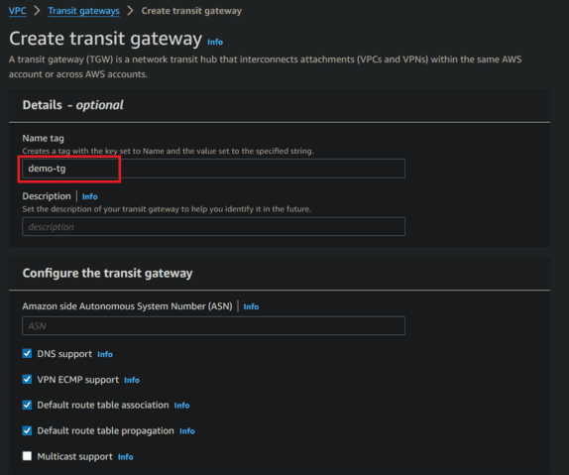
- Now click on create Transit Gateway
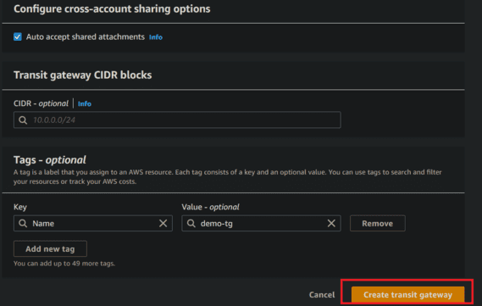
- Here we see transit gateway successfully created
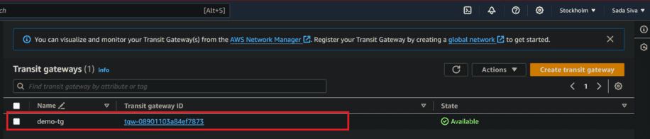
Step 2: Configuring VPCs
- A VPC is an isolated portion of the AWS Cloud populated by AWS objects, such as Amazon EC2 instances.
- Now create two VPCs or select existing VPCs.
- Navigate to VPC Dashboard and click on create VPC.
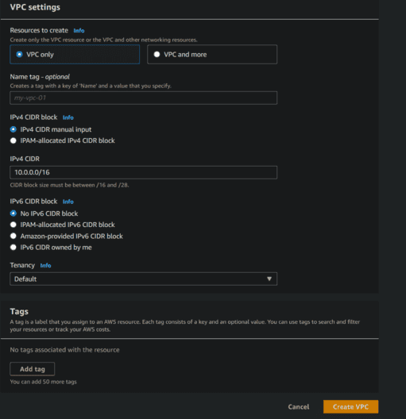
- Same process do for VPC2, VPC3 and VPC4.
- Here we see two VPC are created.
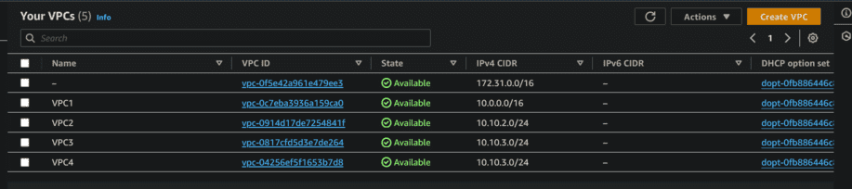
Step 3: Transit Gateway Attachments
- Now select Transit gateway ID which is created in previous step and next select attachment type VPC or VPN.
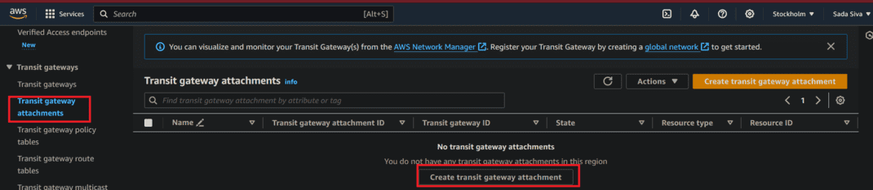
- VPC attachment: Select and configure your VPC attachment.
- VPC ID: Select the VPC1 to attach to the transit gateway.
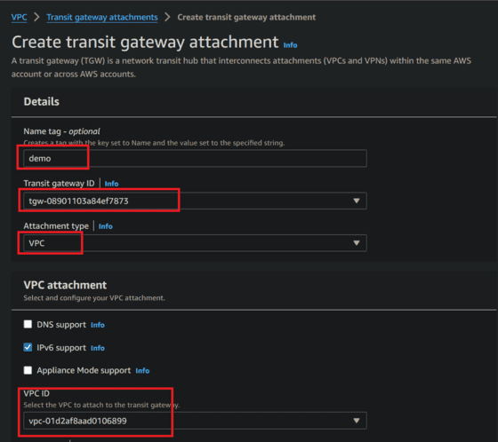
- Now click on Create Transit gateway attachments
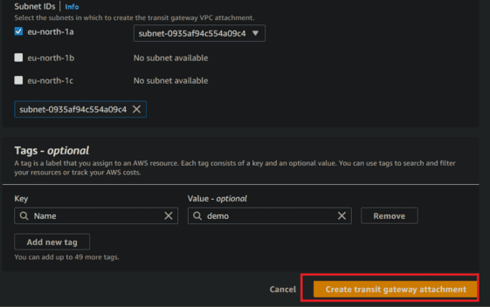
- Same we need to do on VPC2 as well.
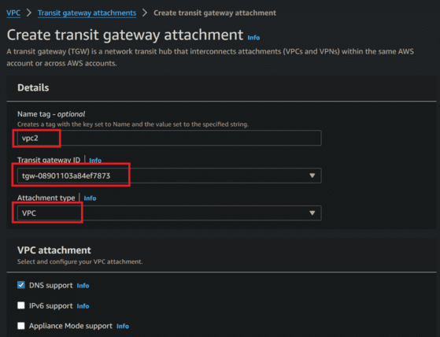
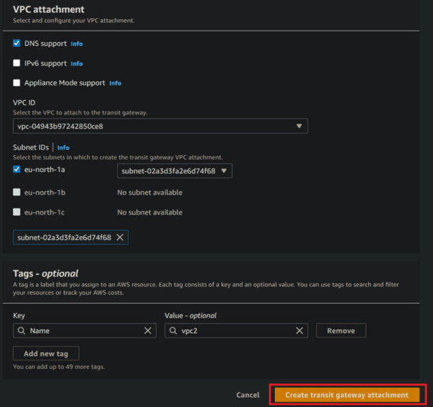
- Here we see VPC1 and VPC2 are attached to transit gateway
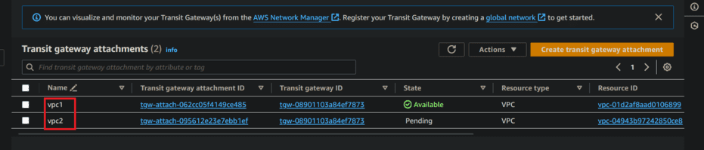
Step 4: Creating route Tables
- In previous step we are created VPC along with Route Table, Now we need to attach our Transit gateway to route table
- Now choose Private route table and navigate to routes
- Click on Edit route and choose add route
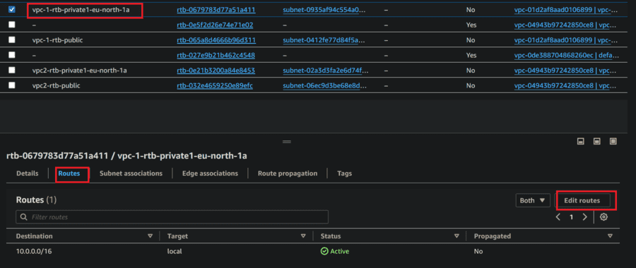
- Set cidr block and in drop down box select Transit gateway and click save changes
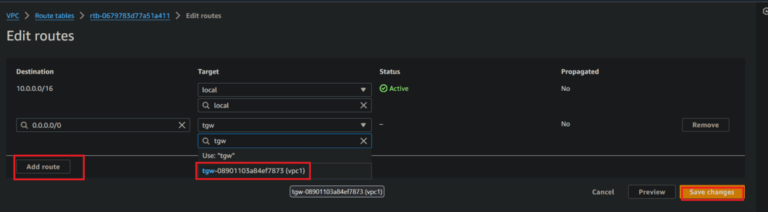
- Route table was updated
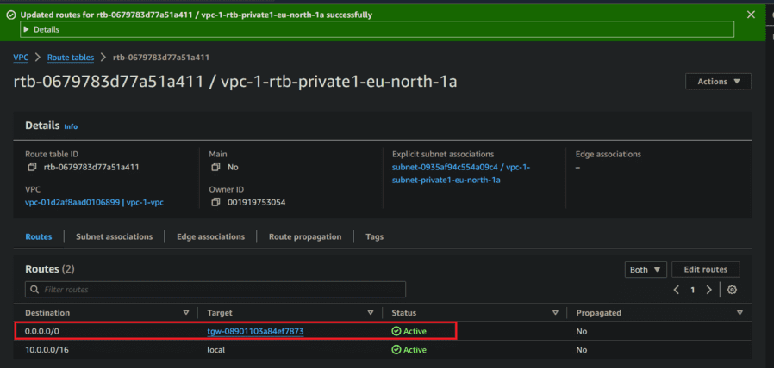
- Now same process we need to do for the VPC2 as well.
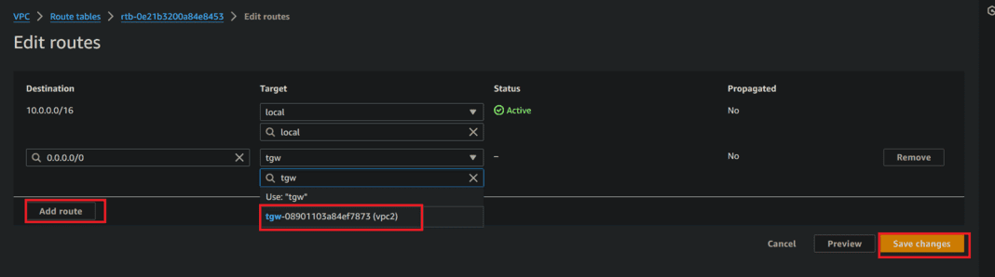
- VPC2 Route table also updated
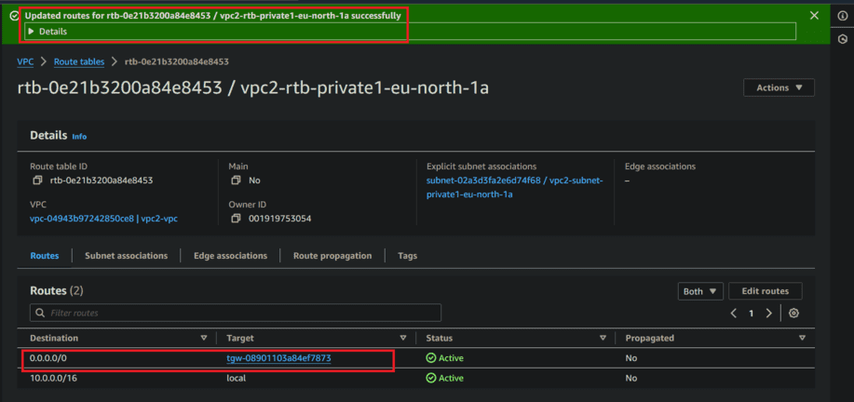
Step 5: Configuring security groups
- Create New Security Groups or select existing security group
- Now edit inbound rules to security groups allow all traffic
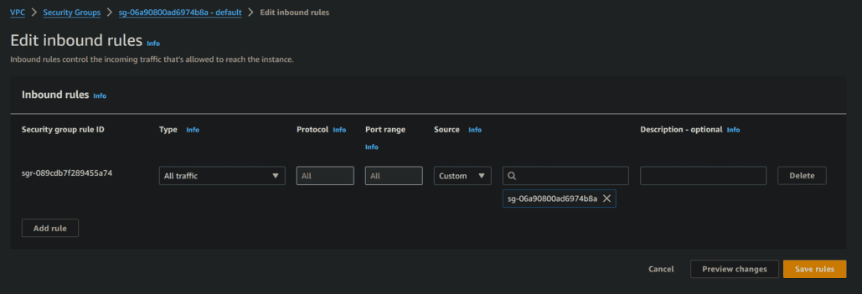
Step 6: Launch EC2 Instance
- While launching instances in network settings choose created VPCs and also choose private subnet as shown in below figure
Instance-1
Launce the instance from the vpc one with the private subnet.
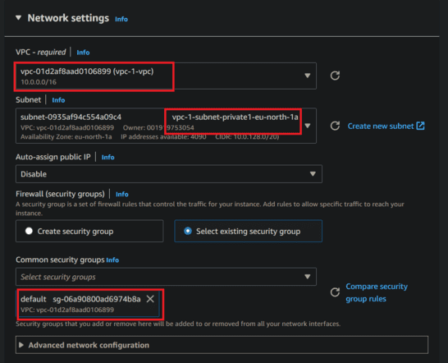
Instance-2
Launce the instance from the vpc two with the public subnet.
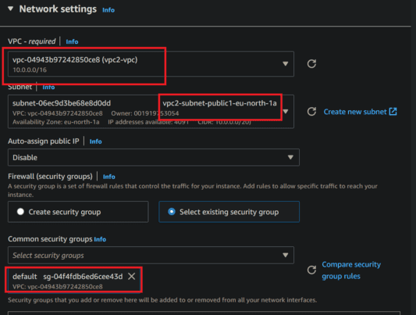
- Now both EC2 instances in their respective VPCs are created., That is VPC1 and VPC2. They can communicate to each other with their private IPs through transit gateway. Here is how we can test it:
- SSH into the Bastion Host and Copy the Keypair .pem File to an EC2 Instance in VPC 1.
Here is the command to be execute in terminal
ssh -i /path/to/your/keypair.pem ec2-user@bastion-host-public-ip
- Now use the scp command to securely copy the keypair .pem file to the desired path in the EC2 instance of VPC 1:
scp -i <keypair name> /path/to/your/keypair.pem ec2-user@ec2-instance-private-ip:/path/to/destination/
- Now change the permission to keypairs file, we are only giving read only permission to key pair file. To change file permissions follow below commands
chmod 400 <keypair name>
- SSH into the EC2 Instance of VPC 1 from the Bastion Host:
- Now we are connecting SSH into the EC2 instance of VPC 1 using its private IP address follow below command
ssh -i /path/to/destination/keypair.pem ec2-user@ec2-instance-private-ip
- Now execute below command
ping <private IP address of 2nd instance>
- When its successfully ping then our connection was successful. When its ping they communicate from one VPC to another VPC
- Here we are doing from vpc1 private IP to connecting to VPC2
Output
Here we see VPC 1 to VPC 2 and VPC3
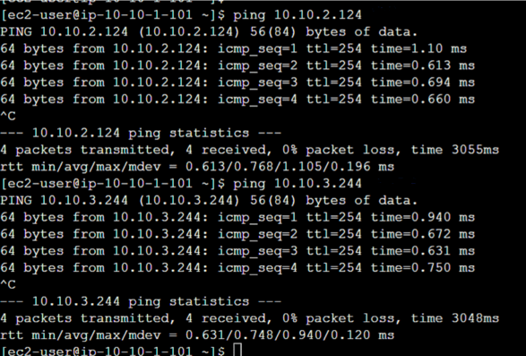
Here we see VPC 2 to VPC 1 and VPC3
